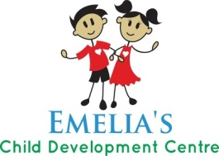
Emelia’s Child Development Centre Daycare/OSC
#202 100 Centre Street St. Albert T8N3W2 Phone: 780-458-5355
Fax: 780-458-9209 Email: emelia.daycare@gmail.com
NEWS LETTER September 2015

1. WELCOME
Hello, new students and parents. We welcome all new families and children to our centre. We assure all our families that we will give the best care to all of the children.
- From, staff.
2. HOLIDAY
The centre will be closed on Monday, September 7, 2015 for Labor Day.

3. SCHOOLS WE SERVE
We serve the following schools for kindergarten and O.S.C children, École Marie Poburan, Neil M Ross Catholic Elementary School, Keenooshayo Elementary School, Leo Nickerson Elementary School, Elmer S Gish School, and Sir Alexander Mackenzie Elementary school. We have space available. Please spread a word to your friends and families.

4. SUMMER PROGRAM  With children and parents, we wrapped up the summer program with the multicultural lunch. We would like to thank the parents who came for the lunch. | 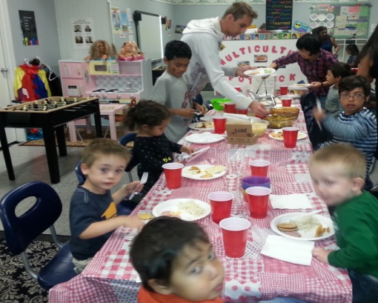
5. PARENT VOLUNTEER  We would like to thank a parent, who volunteered for all the field trips, Mr. Steven Pywell. We appreciated his hard work and participations. | 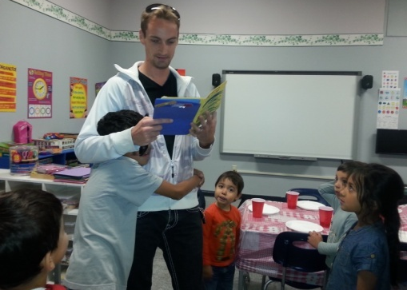

6. ACCREDITATION
Our centre is preparing for accreditation. We hope to get an accreditation done soon.

7. SHOW AND SHARE
We will have Show and Share for children of all age groups every Thursday. Children can bring in here any toys they would like to show and share with their peers.

8. CLOTHINGS
Parents please send proper children`s clothing appropriate for the weather each day. Our children will go down to the play area every day.

